Week 5 – SOFT7019 lab session

This week we will utilise an online C IDE called online gdb, please access it at <https://www.onlinegdb.com/>

In the top right corner, you will have the option to select the programming language, please select C.

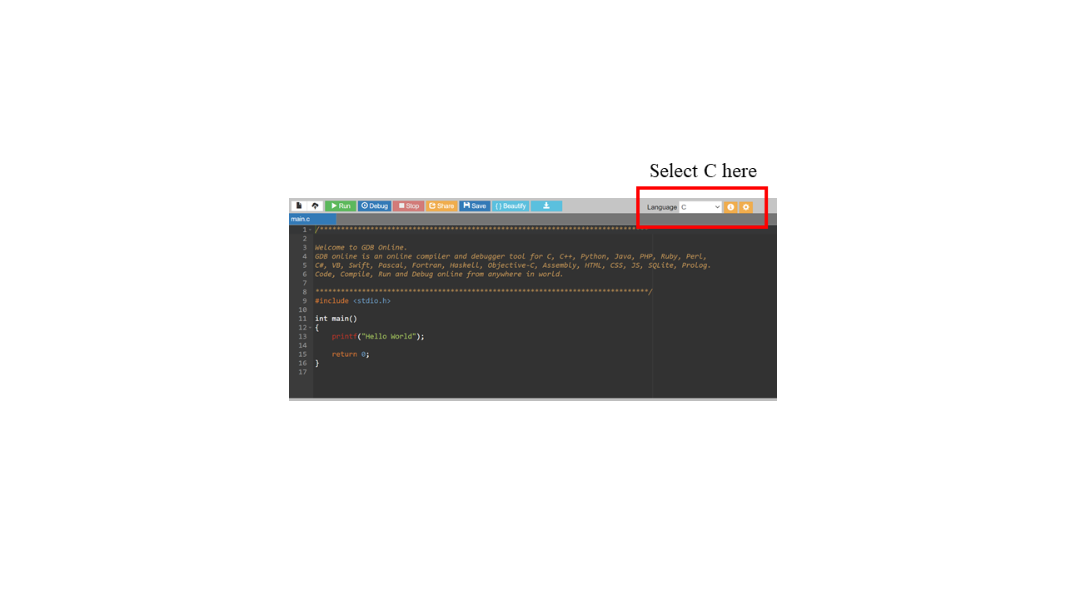

If you have a problem with this IDE, I would recommend installing CodeBlocks on your local machine. Last week we saw long lag times and errors ub the onlinegdb.com website during some of the lab sessions. I would recommend this guide to follow if installing CodeBlocks:

<https://www.youtube.com/watch?v=GWJqsmitR2I>

# Exercise 1

**Reading a 2D array of chars**

# define a 2D array of chars with 4 rows and 4 columns

# read in a string of characters

# fill in the array with the characters; if there are more than 16 characters, discard them; if less, fill in with spaces (’ ’)

Sample run 1

Input:

>thisisatestthisisatest

Output:

t h i s

i s a t

e s t t

h i s i

Sample run 2

Input:

>testtesttest

Output:

t e s t

t e s t

t e s t

# # # #

Example code for exercise 1:

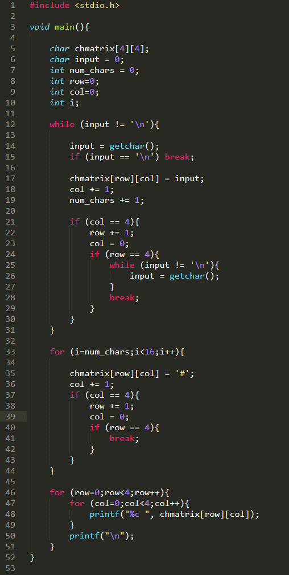

# Exercise 2

**Reading and searching through 2D arrays of chars**

# read a 2D array of chars as shown in exercise 1

# read in a char

# go through the elements of the array

# print the coordinates (row, col) of all the occurrences of the char.

Sample run 1

Input:

>this is a test this is a test

Output:

t h i s

i s

a t e s

t t h

>Search for char: i

0 2

1 1

# Exercise 3

**Reading and printing 2D arrays of chars**

# read a 2D array of chars as shown in exercise 1

# take in a coordinate (row and column)

# print the square of characters that has the character at the given coordinate in the bottom right corner; see sample runs below for clarity

Sample run 1

Input:

> testblobmrimcrac

Output:

t e s t

b l o b

m r i m

c r a c

Row number:3

Col number:3

i m

a c

# watch out for the edges of the array, don’t go out of bounds!